Student Getting Started

STEP 1: Before You Register

1. Visit the website for your course www.myspanishlab.com and click Browser Tune-up to confirm that you have met the Systems Requirements.

2. Confirm that you have the following needed to register:
- Valid Email Address
- Student Access Code - packaged with your text or available standalone at the bookstore. (You may also purchase instant access online from the website for your course).
- Your Instructor’s Section/Course ID: CRSCDU6-204258

STEP 2: Register for Your Course

Go to the website for your course www.myspanishlab.com Under “Register or Buy Access,” click Students, and follow the registration instructions. If you need help, click the link for the “step-by-step tutorial” on how to register.

STEP 3: Login to Your Course
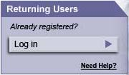
Go to the website for your course www.myspanishlab.com Click the Log in button under the “Returning Users” and enter the Login Name and Password you created.

STEP 4: Set Your Time Zone

Click My Profile after signing in to your course. Select your Time zone from the menu.
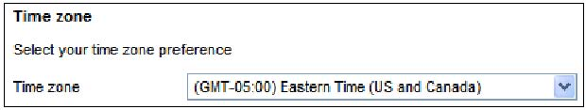
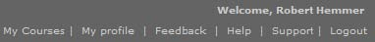

STEP 5: Set Pop-Up Blockers

Some browsers will block all pop-ups—even those you want! To allow pop-ups for your MyLab, open your browser and do the following (there may be some variations with each browser): Click Tools → Pop-up Blocker → Pop-up Blocker Settings. When prompted for “Address of Website to allow”, enter: *.pegasus2.pearsoned.com

Enrolling in a Course

STEP 1: Before You Enroll

1. Go to the website for your course www.myspanishlab.com Click on Browser Tune-up to confirm that you have met the Systems Requirements.

2. Confirm that you have the following needed to register:

Instructor’s Section/Course ID: CRSCDU6-204258

STEP 2: Enroll in Your Course

1. Go to the website for your course www.myspanishlab.com. Click the Log in button under the “Returning Users” and enter the Login Name and Password you created. A “Forgot Login name or Password?” is available if you’re not sure!
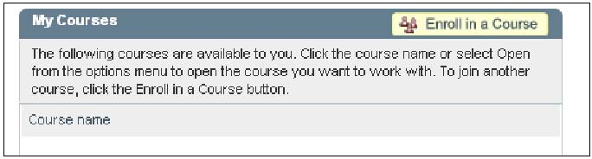
2. On the “My Courses” page, click Enroll in a Course.
3. Type the Course ID provided by your instructor.
4. On the Confirm Course screen, verify that the Course ID you entered matches your instructor’s course. Click Next.
5. On the Summary screen, confirm the information is correct and then click Enter Course Now to enter your instructor’s course. You now have access to your resources!

STEP 3: Set Your Time Zone

Click My Profile after signing in to your course. Select your Time zone from the menu.
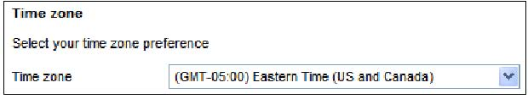

STEP 4: Set Pop-Up Blockers

Some browsers will block all pop-ups—even those you want! To allow pop-ups for your MyLab, open your browser and do the following (there may be some variations with each browser): Click Tools → Pop-up Blocker → Pop-up Blocker Settings. When prompted for “Address of Website to allow”, enter: *.pegasus2.pearsoned.com

Student Getting Started
2 of 2

