**Enrolling in a Course**

STEP 1: Before You Enroll

1. Go to the website for your course [www.myspanishlab.com](http://www.myspanishlab.com/)

2. Confirm that you have the following needed to register:

**Instructor’s Section/Course ID:** **CRSCDDX-207444**

STEP 2: Enroll in Your Course

1. Go to the website for your course [www.myspanishlab.com](http://www.myspanishlab.com/). Click the **Log in** button under the “Returning Users” and enter the Login Name and Password you created. *A “Forgot Login name or Password?” is available if you’re not sure!*

2. On the “My Courses” page, click **Enroll in a Course.**

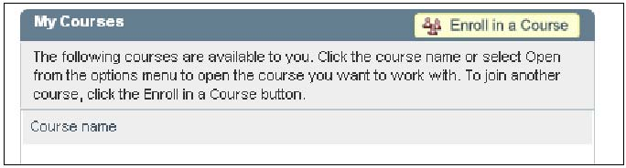

3. Type the **Course ID** provided by your instructor.

4. On the Confirm Course screen, verify that the Course ID you entered matches your instructor’s course. Click **Next**.

5. On the Summary screen, confirm the information is correct and then click **Enter Course Now** to enter your instructor’s course. You now have access to your resources!