Look what the 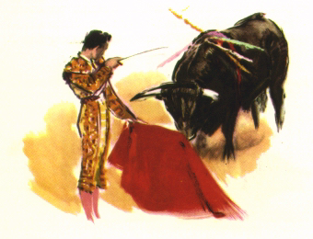DEPARTAMENTO DE ESPAÑOL
has for you!!

How to get a Major or Minor in Spanish:

Minor - A minimum of 18 credit hours (3 full courses)

Year 1: Span 1013/1023 Introductory Spanish Language (6 credit hours)
Year 2: Span 2013/2023 Intermediate Spanish (6credit hours)
Year 2 or 3: Span 2113/2123 Spanish Conversation (6 credit hours)
Year 3: Span 3103/3203 Advanced Grammar and Conversation (6 credit hours)*

Major - A minimum of 36 hours of Spanish (6 full hours)

Year 1: Span 1013/1023
Year 2: Span 2013/2023
Span 2113/2123
Year 3: Span 3103/3203
Years 3 & 4: Span 3213/3223 Peninsular Literature
Span 3313/3323 Translation and Stylistics
Span 3413/3423 Spanish American Literature

Honours - A minimum of 42 hours, plus a thesis.
All the above courses plus any of the following:

Span 4013 Special Topics: Business Language**
Span 4023 Special Topics: Administrative Practices & Cultural Contexts**
Span 4413/4423 Special Topics: Peninsular Literature or Civilization
Span 4513/4523 Special Topics: Spanish American Literature or
Civilization

Joint BBA & Spanish - 48 hours of Spanish + a year abroad (existing
contacts include Chile and Spain)

* This course may be taken instead of or in addition to Span 2113/2123
** These courses are especially offered for students in the School of Business Administration.

